Create the User list webpage along with Add New/Edit and Delete feature.

1. Create User List by calling Reqres.in rest API service to pull the data.

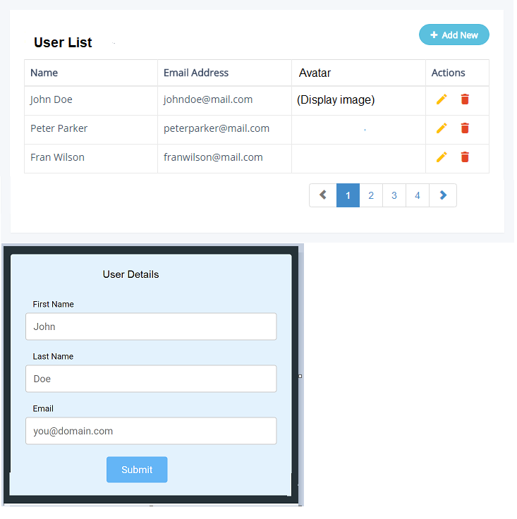

1. Click “Add New ” button opens the model window ( or show the form below User List) to collect User details to add it to the list. Click on Submit must save the details
2. Click “Edit” in the action button open the same User Details page for editing. Click on Submit will modify the changes.
3. Click on Delete button request for confirmation before proceeding.

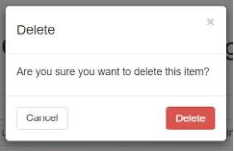

Use <https://reqres.in/> services for the above operations.

Guidelines

1. User HTML, CSS, Bootstrap and javascript/ jQuery.
2. Refer online to get the assignment done.
3. No discussion by each other.